**GIT TASK**

**SUKESHVARMA**

1. Initialize an empty Git repository on your local machine with the name

**“gitlocal”** and make a **README.md** file in that directory which should contain

your name as a heading and a hello message (<https://www.makeareadme.com/>)

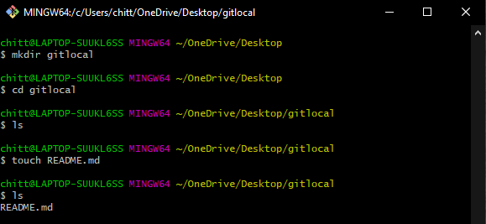

1. Now check the status of your git directory and push all the files in that

directory to your GitHub repo which you have made in the first step. With a

massage “First Commit to Git Repo”.

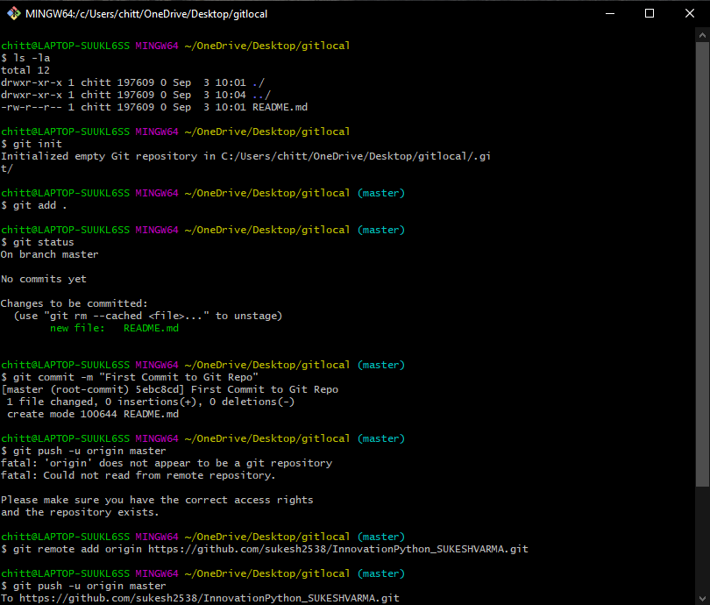

1. Now add a file to your GitHub repo named “demo.txt” from the GitHub console

with content: “This is the demo file before modifications”.

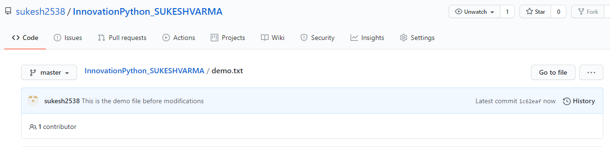

1. Pull the changes in your Git repo to your local machine git directory named **“gitlocal”** and check the status for the modifications done in that repo. This time demo should be visible in your local machine.

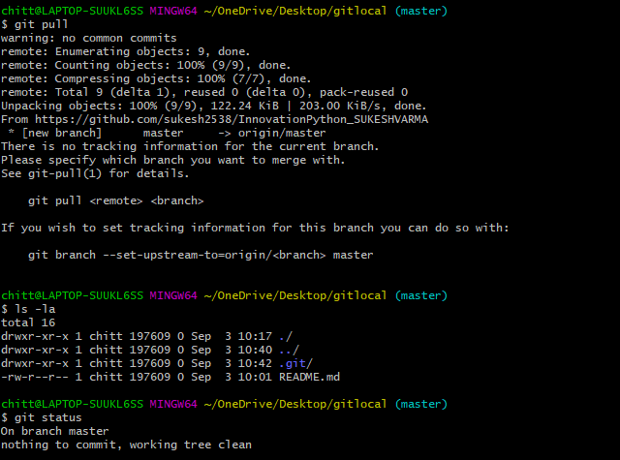

1. Now make a new branch in your local machine with the name “**developer”**.

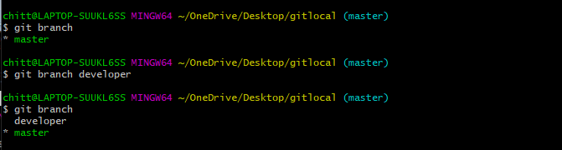

1. Edit that demo file and write some content in that eg: “This is a demo file after modification” and push the modifications to your GitHub repo from the **developer** branch with a commit message “Commit from developer branch”.

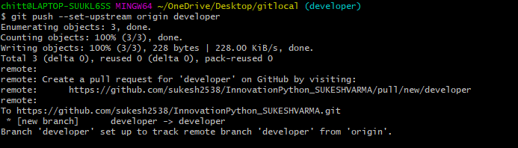

1. Go to the GitHub console and generate a merge request to master branch after checking the modifications.
2. After merging you could see the modified content in the demo file.

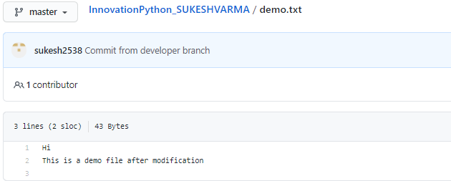

1. Now revert back to the previous version from terminal. After switching back to the previous version your demo file should have the content: This is a demo file before modification.
2. At the end delete the developer branch.
3. 